COIMBATORE INSTITUTE OF TECHNOLOGY
(Government aided Autonomous Institution Affiliated to Anna University)
COIMBATORE – 641014
ANNA UNIVERSITY::CHENNAI 600 025
BONAFIDE CERTIFICATE
Certified that this Internship report is the bonafide work of DHANYA R (2303717610422074)

---------------------------------------------  Dr.A.N.SENTHILVEL B.E.,M.S.,Ph.D  Professor  Department of Computer Science and Engineering,  Coimbatore Institute of Technology,  Coimbatore – 641 014. |  | ----------------------------------------  Dr.A.KUNTHAVAI M.S.,Ph.D  Professor and Head  Department of Computer Science and Engineering,  Coimbatore Institute of Technology,  Coimbatore – 641 014.

Submitted for the evaluation held on ________________

------------------- --------------------- ---------------------
Reviewer 1 Reviewer 2 Reviewer 3

DETAILS OF INTERNSHIP UNDERGONE

Reg. No.: 2303717610422074
Name of the Student: DHANYA R
Degree: B.E.
Branch: Computer Science and Engineering
Semester: V
Project Title : IoT-Enabled Fire Safety Monitoring and Alert Mechanism

S. No. | Name and Address of the Company | Period of Internship undergone |  | No. of Days
S. No. | Name and Address of the Company | From | To | No. of Days
1. | Protowiz Technologies | 19.05.2025 | 02.06.2025 | 15 days
Total Number of Days: |  |  |  | 15 days

Signature of Student Signature of Tutor

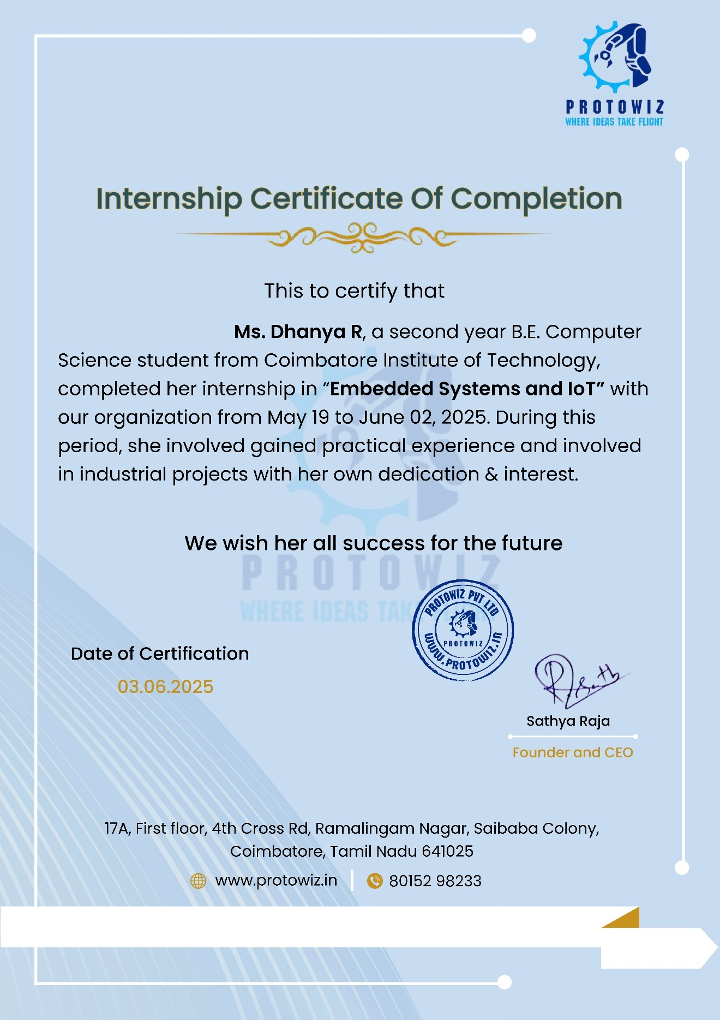
ACKNOWLEDGEMENT
I extend my heartfelt gratitude to (ProtoWiz Technologies) for permitting me to undergo internship their industries/organizations and their guidance to upgrade my theoretical and practical skills in engineering.
I am sincerely grateful to the Management of Coimbatore Institute of Technology, Coimbatore for supporting me in every possible way, for undergoing internship in industries.
I sincerely thank our Principal Dr. A. Rajeswari, M.E., Ph.D., Coimbatore Institute of Technology, Coimbatoreand Head of the Department DrKunthavai A, M.S., Ph.D., Department of Computer Science and Engineering, Coimbatore Institute of Technology, Coimbatore for including industrial training pattern in the curriculum to enrich students with a sound knowledge in engineering and make them industry ready. I am also obliged for permitting me to undergo the training.
I also extend my thanks to the Senior Tutor, Tutors, Teaching faculty and all other supporting staff members of the department for their support and encouragement to take up the internship in industries.
DHANYA R

TABLE OF CONTENTS

CHAPTER  No. | TITLE | PAGE  No.
 | LIST OF ABBREVIATION | 10
1 | INTRODUCTION | 12
 | 1.1 PROJECT SCOPE AND OBJECTIVE | 12
 | 1.2 MODULES | 13
2 | SOFTWARE REQUIREMENTS SPECIFICATIONS | 15
 | 2.1 FUNCTIONAL REQUIREMENTS | 15
 | 2.2 NON FUNCTIONAL REQUIREMENTS | 15
 | 2.3 SOFTWARE STACK | 16
 | 2.4 HARDWARE STACK | 16
3 | SYSTEM ARCHITECTURE AND DESIGN | 17
 | 3.1 OVERVIEW | 17
 | 3.2 KEY COMPONENTS AND RESPONSIBILITIES | 17
 | 3.3 DIAGRAMS | 19
4 | TECHNOLOGY USED | 21
 | 4.1 FRONT END TECHNOLOGY | 21
 | 4.2 BACK END TECHNOLOGY | 21
 | 4.3 ADDITIONAL TECHNOLOGIES | 22
5 | CODING | 22
 | 5.1 BACKEND MODULE | 22
 | 5.3 FRONTEND MODULE | 25
6 | SCREENSHOTS | 35
7 | CONCLUSION | 41
8 | BIBILOGRAPHY | 42

LIST OF ABBREVIATION

Abbreviation | Expansion
IoT | Internet of Things
HTTP | HyperText Transfer Protocol
API | Application Programming Interface
GPS | Global Positioning System
ESP32 | Espressif Systems 32-bit Microcontroller
MQ | Metal Oxide (Gas Sensor)
DHT | Digital Humidity and Temperature Sensor
LED | Light Emitting Diode
Wi-Fi | Wireless Fidelity
IP | Internet Protocol
IDE | Integrated Development Environment
URL | Uniform Resource Locator
LCD | Liquid Crystal Display
JSON | JavaScript Object Notation
Thinspeak | Platform for IoT Mobile and Web Dashboard

WEEKLY OVERVIEW OF INTERNSHIP ACTIVITIES

1stWEEK | DATE | DAY | NAME OF THE TOPIC/MODULE COMPLETED
1stWEEK | 19.05.25 | Monday | Introduction to Basic Electronics  Introduction to basic electronics componenets  Introduction to Arduino IDE  Installation of Arduino IDE  LED Blink  LED Blink with PotentioMeter.
1stWEEK | 20.05.25 | Tuesday | Intruder Alert System.  Weather Monitoring System
1stWEEK | 21.05.25 | Wednesday | Pollution Monitoring System  Waterlevel Monitoring System
1stWEEK | 22.05.25 | Thursday | Distance Monitoring System  Intelligent Garbage Can
1stWEEK | 23.05.25 | Friday | Clap Switch  Soil Monitoring System
1stWEEK | 24.05.25 | Saturday | LED Display Board  Flood Management System

2ndWEEK | DATE | DAY | NAMEOFTHETOPIC/MODULECOMPLETED
2ndWEEK | 25.05.25 | Sunday | Smart Security System  DashBoard:Webserver and thinkspeak
2ndWEEK | 26.05.25 | Monday | Smart garbage Can  DashBoard:WebServer and Thinkspeak
2ndWEEK | 27.05.25 | Tuesday | LED Display Board
2ndWEEK | 28.05.25 | Wednesday | Air Quality Monitoring System,DashBoard:Blynk
2ndWEEK | 29.05.25 | Thursday | Smart irrigation System,DashBoard:Blynk
2ndWEEK | 30.05.25 | Friday | Smart Helmet,DashBoard:Blynk
 | 31.05.25 | Saturday | Project Development
 | 01.06.25 | Sunday | Project Development
 | 02.06.25 | Monday | Project Development

1. INTRODUCTION
In recent years, fire accidents have become one of the major causes of property damage and loss of life worldwide. Early detection and timely alert are crucial to minimizing such incidents. Traditional fire detection systems rely on smoke detectors or manual observation, which often result in delayed responses. To overcome these limitations, Internet of Things (IoT)-based fire detection systems are gaining popularity due to their ability to provide real-time monitoring and instant alerts.
This project, “IoT-Enabled Fire Safety Monitoring and Alert Mechanism”, is designed to detect fire hazards by continuously monitoring temperature and gas concentration in the environment. The system utilizes sensors such as DHT22 (for temperature) and MQ2 (for gas detection) connected to an ESP32 microcontroller, which transmits data to an IoT platform. The system triggers an alert when certain threshold conditions are met (e.g., temperature above 45°C and/or gas level above 400 ppm). Additionally, it sends notifications via Telegram Bot and updates the data on ThingSpeak jvvv for remote monitoring.
The solution is cost-effective, highly scalable, and suitable for deployment in homes, industries, warehouses, and forest regions. By integrating real-time data monitoring, cloud connectivity, and alert mechanisms, the proposed system aims to reduce the response time in case of fire hazards, thereby preventing severe damage and saving lives.

1.1 PROJECT SCOPE AND OBJECTIVE

SCOPE
The IoT-enabled Fire Safety Monitoring and Alert System is designed to enhance fire detection and emergency response through real-time monitoring and instant alert notifications. The scope of this project includes:
- Continuous Monitoring: Real-time data acquisition of temperature and gas concentration levels using IoT sensors.
- Multi-Location Support: Monitoring fire risk at multiple sites (e.g., Bangalore and Chennai) through a centralized IoT dashboard.
- Remote Accessibility: Providing a web-based and mobile-enabled platform (ThingSpeak dashboard) for visualizing sensor data from any location.
- Instant Alerts: Triggering Telegram notifications and SMS alerts when predefined thresholds are exceeded (e.g., temperature > 45°C and gas > 400 PPM).
- Location-Based Alerts: Integrating GPS or region-specific alerts to identify and notify the exact location of fire hazards.
- Authentication and Security: Implementing a login system to ensure secure access to the dashboard and system data.
- Scalability: Designing the system to integrate additional sensors or locations in the future without major architectural changes.

OBJECTIVES
The primary objectives of this project are:
- To develop an IoT-based solution for fire detection using temperature and gas sensors.
- To provide real-time monitoring of environmental parameters on an online dashboard.
- To ensure early detection and rapid response by sending alerts through Telegram messages and SMS notifications.
- To incorporate location-based information for identifying the exact site of the fire incident.
- To design a user-friendly, secure dashboard for monitoring multiple locations.
- To enhance fire safety management through automation and remote accessibility.

1.2 MODULES

1. Sensor Data Acquisition Module
- Components: Temperature Sensor (DHT22), Gas Sensor (MQ2 or similar)
- Functionality:
  - Continuously reads temperature and gas concentration values.
  - Detects abnormal conditions (e.g., high temperature or high gas concentration).
  - Sends the collected data to the microcontroller (ESP32/Arduino).

2. IoT Communication Module
- Components: ESP32 / NodeMCU, Wi-Fi Connectivity
- Functionality:
  - Transmits the collected sensor data to the cloud (ThingSpeak).
  - Ensures real-time data communication.
  - Maintains a secure connection for data integrity.

3. Data Monitoring and Visualization Module
- Components: ThingSpeak Cloud Platform
- Functionality:
  - Displays real-time sensor data in the form of charts and gauges.
  - Allows multi-location data representation (e.g., Bangalore & Chennai dashboards).
  - Enables remote monitoring via web or mobile access.

4. Alert and Notification Module
- Components: Telegram Bot API / SMS Gateway
- Functionality:
  - Continuously checks for threshold violations (e.g., temperature > 45°C, gas > 400 PPM).
  - Sends instant alerts via Telegram messages and SMS to registered users.
  - Includes alert details like location, time, and detected values.

5. Authentication & Security Module
- Functionality:
  - Provides secure login for dashboard access.
  - Maintains user authentication for system operations.
  - Ensures only authorized personnel receive critical alerts.

6. Location Management Module
- Functionality:
  - Handles multiple locations (e.g., Bangalore, Chennai).
  - Associates each sensor data set with its respective location.
  - Helps identify the exact site of a fire incident for faster response.

7. Database & Logging Module
- Functionality:
  - Stores historical data for analysis and reporting.
  - Maintains event logs for fire detection and alerts.
  - Provides data backup for future reference.

2. SOFTWARE REQUIREMENTS SPECIFICATION (SRS)

2.1 FUNCTIONAL REQUIREMENTS
These define what the system should do:
- Sensor Data Collection
  - The system shall collect temperature data from the DHT22 sensor.
  - The system shall collect gas/smoke concentration data from the MQ2 sensor.
- Threshold Monitoring
  - The system shall continuously monitor temperature and gas levels.
  - The system shall detect a fire alert condition if:
    - Temperature > 45°C AND Gas > 400 (OR as per modified condition).
- Alert Generation
  - The system shall trigger an alert when fire conditions are detected.
  - The system shall turn on an LED or buzzer for a visual/audible alert.
- IoT Data Transmission
  - The system shall send real-time data (temperature, gas values, and fire status) to ThingSpeak or another IoT platform.
- Location Tracking
  - The system shall provide GPS coordinates of the detected fire location.
- Telegram Alert Notification
  - The system shall send an instant alert message to Telegram with:
    - Fire status
    - Temperature and gas values
    - GPS location (Google Maps link)
- Dashboard Visualization
  - The system shall display real-time sensor data and fire alerts on an IoT dashboard.

2.2 NON-FUNCTIONAL REQUIREMENTS
These define how the system should perform:
- Performance
  - The system should detect fire conditions within 2 seconds of sensor readings.
- Reliability
  - The system should work continuously without failure for at least 24 hours.
- Scalability
  - The system should allow adding more sensors and modules in the future.
- Usability
  - The alert messages should be clear and contain all necessary details for quick action.
- Security
  - The system should ensure that API keys, Telegram bot tokens, and sensitive data are kept secure.
- Low Power Consumption
  - The system should minimize power usage to allow longer operation on limited power sources.
- Network Dependency
  - The system should reconnect automatically if Wi-Fi or network connection is lost.
- Accuracy
  - Temperature and gas sensors should provide accurate readings with a maximum error of ±2°C for temperature and ±10% for gas concentration.

2.3 HARDWARE STACK
- ESP32 (Microcontroller with Wi-Fi for IoT integration)
- DHT22 Sensor (Temperature & Humidity Sensor)
- MQ2 Sensor (Gas/Smoke Detection Sensor)
- LED (Fire Alert Indicator)
- Buzzer (Optional for audible alert)
- Power Supply (Battery or USB)
- Connecting Wires & Breadboard
- GPS Module (Optional) – If you are using actual GPS hardware; otherwise, you can use static location or mobile GPS.

2.4 SOFTWARE STACK
- Arduino IDE – For ESP32 programming and firmware upload
- ThingSpeak – IoT cloud platform for data logging and visualization
- Telegram Bot API – For instant alert notifications
- Twilio API (Optional) – For sending SMS alerts
- C – Programming language for microcontroller code
- Wi-Fi Network – For ESP32 internet connectivity
- Google Maps API (Optional) – For location link generation
- Python (Optional) – If you want to process ThingSpeak data or create additional dashboards

3 .SYSTEM ARCHITECTURE AND DESIGN

3.1 OVERVIEW
The system architecture is designed to monitor environmental conditions such as temperature and gas concentration using IoT-enabled sensors and provide real-time alerts through ThingSpeak, Telegram notifications, and SMS messages. The architecture integrates sensing, data transmission, cloud processing, and alert mechanisms. It ensures timely detection of fire hazards and immediate notification to the concerned authorities or users.
The overall workflow:
- Sensors collect temperature and gas data.
- ESP32 sends the data to ThingSpeak Cloud.
- ThingSpeak triggers an alert mechanism (Telegram bot & SMS API) if thresholds are exceeded.
- Users receive alerts with location details.
- The dashboard displays real-time sensor data and fire status.

3.2 KEY COMPONENTS & RESPONSIBILITIES

a) ESP32 Microcontroller
- Collects sensor readings (temperature & gas levels).
- Connects to Wi-Fi and transmits data to ThingSpeak.
- Implements alert logic for fire detection.

b) Sensors
- DHT22: Measures temperature and humidity.
- MQ2: Detects smoke/gas concentration.

c) ThingSpeak Cloud
- Stores and visualizes sensor data.
- Provides API to trigger alerts.
- Enables data analytics and monitoring.

d) Notification System
- Telegram Bot API: Sends fire alerts with location.
- SMS Gateway (Twilio/Similar): Sends text alerts.

e) User Interface
- ThingSpeak Dashboard: Displays real-time graphs and data.
- Telegram Alerts: Instant fire notifications.
- Optional Mobile App/Web App: For additional control and monitoring.

3.3 DIAGRAMS:
A-USE CASE DIAGRAM:

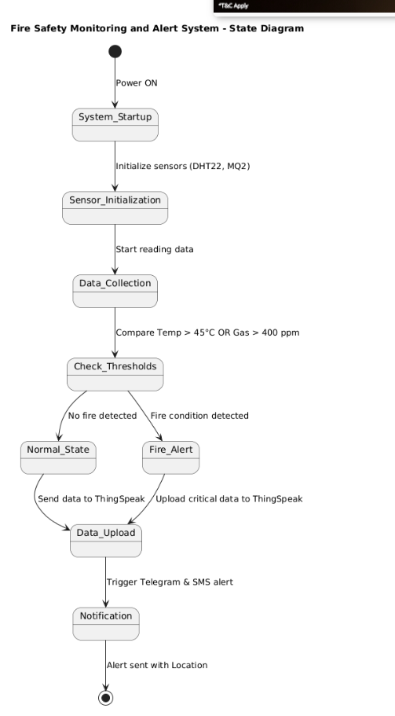

B — Sequence Diagram:
1. User Authentication & System Initialization
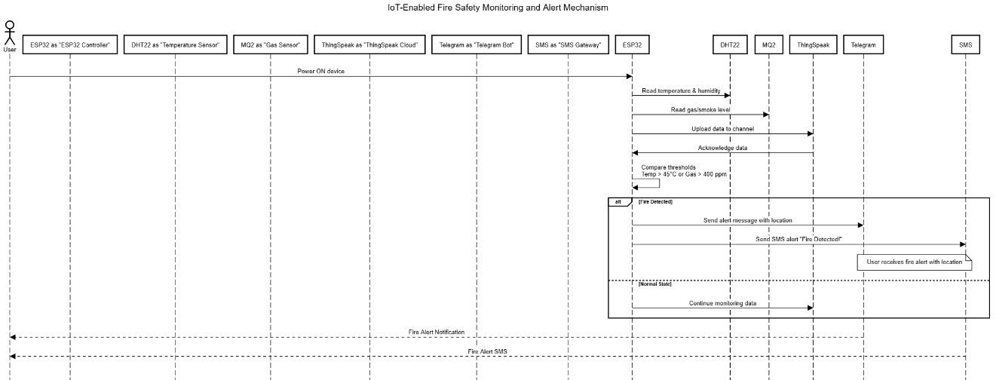
2. Fire Detection & Alert Mechanism
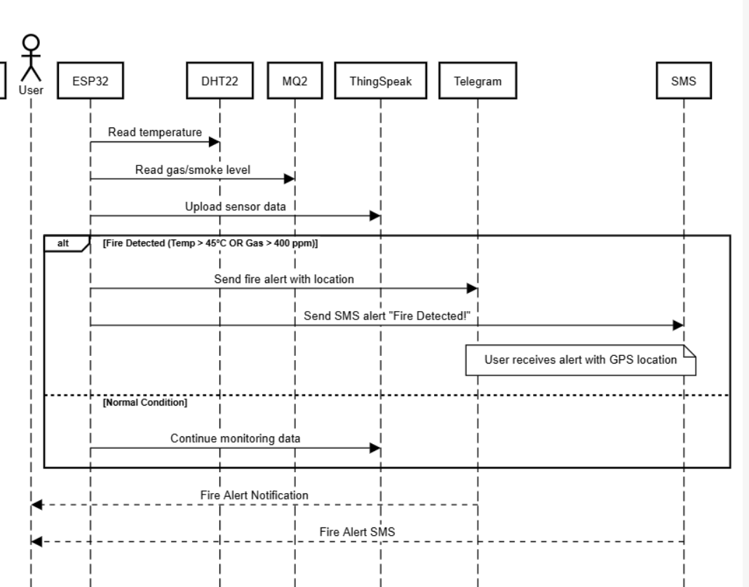

4. TECHNOLOGY USED
The proposed Electricity Monitoring and Management System has been developed using a combination of frontend, backend, database, and IoT technologies. Each technology has been chosen with the intent of achieving real-time monitoring, user-friendly visualization, reliable storage, and efficient communication between IoT devices, server, and end-users. The detailed description of technologies is given below.

4.1 FRONTEND TECHNOLOGY
These handle the user interaction and visualization.
- HTML (HyperText Markup Language)
  - Used for creating the structure of the login page and dashboard UI.
  - Defines elements like forms, buttons, and tables for displaying data.
- CSS (Cascading Style Sheets)
  - Provides styling for the web pages, such as colors, fonts, and layout.
  - Ensures the login page and dashboard look neat and user-friendly.
- JavaScript
  - Handles client-side interactivity like validating login form and showing real-time alerts on the dashboard.
  - Can fetch the latest sensor readings from ThinkSpeak or your backend via API calls.

4.2 BACKEND TECHNOLOGY
These manage data processing, logic, and integration with IoT & alert services.
- Arduino IDE / ESP32 Firmware
  - Used to program the ESP32 microcontroller.
  - Handles sensor data collection (temperature from DHT22, smoke/gas from MQ2).
  - Sends data to ThinkSpeak using HTTP or MQTT.
- ThinkSpeak
  - A cloud IoT analytics platform for storing, analyzing, and visualizing sensor data.
  - Supports real-time monitoring and triggers alerts via ThingSpeak React or MATLAB analysis.
- Telegram Bot API
  - Sends real-time location-based fire alerts to Telegram groups or individuals.
  - Useful for community alert and easy communication.
- SMS Notification (via API like Twilio / Fast2SMS)
  - Sends an emergency SMS alert when fire conditions (Temp > 45°C OR Gas > 400 ppm) are detected.
  - Alerts include fire detected message + location link.
- HTTP/MQTT Protocols
  - Used for data transmission between ESP32 and ThinkSpeak.
  - Ensures secure and reliable communication.

3. Additional Technologies
These are extra services and tools that make the system complete:
- Google Maps API / GPS Module (NEO-6M)
  - GPS module provides the latitude and longitude of the fire location.
  - Google Maps API converts this into a clickable map link for Telegram and SMS alerts.
- PlantUML
  - Used for creating state diagrams, sequence diagrams, and architecture diagrams in SRS documentation.
- MATLAB (in ThinkSpeak)
  - For alert condition evaluation (Temp > 45°C OR Gas > 400 ppm).
  - Can trigger alerts using ThinkSpeak’s React feature.

5. CODING
The system has been divided into three modules for clarity and maintainability:
- Backend Module (Node.js + Express)
- Database Module (MySQL)
- Frontend Module (React.js)

5.1 BACKEND MODULE (NODE.JS + EXPRESS)
The backend provides APIs for fetching usage logs, sending messages, and managing admin/user interactions.
Embedded Systems Part:
#include <WiFi.h>
#include <HTTPClient.h>
#include "DHT.h"

#define DHTPIN 15 // DHT22 connected to GPIO 15
#define DHTTYPE DHT22
#define GAS_SENSOR 34 // MQ2 AOUT connected to GPIO 34
#define LED_PIN 13 // LED for fire alert

const char* ssid = "Wokwi-GUEST"; // Wokwi virtual WiFi
const char* password = ""; // No password
const char* apiKey = "VA0CAOMQWO0GEJVY"; // 🔴 Replace with your ThingSpeak API key
const char* server = "http://api.thingspeak.com/update";

DHT dht(DHTPIN, DHTTYPE);
String location = "Chennai%2C%20India"; // Already URL encoded
String latitude = "13.067439";
String longitude = "80.237617";
void setup() {
Serial.begin(115200);
dht.begin();
pinMode(GAS_SENSOR, INPUT);
pinMode(LED_PIN, OUTPUT);

// Connect to WiFi
Serial.print("Connecting to WiFi");
WiFi.begin(ssid, password, 6);
while (WiFi.status() != WL_CONNECTED) {
delay(100);
Serial.print(".");
}
Serial.println(" Connected!");
}

void loop() {
float temperature = dht.readTemperature();
int gasValue = analogRead(GAS_SENSOR);

Serial.print("Temperature: ");
Serial.print(temperature);
Serial.print(" °C\tGas: ");
Serial.println(gasValue);

if (temperature > 45 && gasValue > 400) {
Serial.println("🔥 FIRE DETECTED!");
Serial.println("📍 Location: " + location);
Serial.println("🌐 Coordinates: Latitude: " + latitude + ", Longitude: " + longitude);
digitalWrite(LED_PIN, HIGH);
} else {
digitalWrite(LED_PIN, LOW);
}

// Send to ThingSpeak
if (WiFi.status() == WL_CONNECTED) {
HTTPClient http;
String url = String(server) + "?api_key=" + apiKey +
"&field1=" + String(temperature) +
"&field2=" + String(gasValue)+
"&field3=" + location +
"&field4=" + latitude +
"&field5=" + longitude;
Serial.println("Sending to URL: " + url);
http.begin(url);
int httpCode = http.GET(); // Send the request

if (httpCode > 0) {
Serial.println("📶 Data sent to ThingSpeak.");
} else {
Serial.print("❌ Error sending data: ");
Serial.println(http.errorToString(httpCode).c_str());
}
http.end();
}

delay(20000); // ThingSpeak requires 15-20 seconds between updates
}

File: backend/server.js
// server.js
const express = require('express');
const cors = require('cors');
const bodyParser = require('body-parser');
const axios = require('axios');

const app = express();

app.use(cors());

app.use(bodyParser.json());

const TELEGRAM_BOT_TOKEN = "7858716669:AAHy3UgUWB5HxMBOAc_qHnPFA4HKN__KabQ";

const TELEGRAM_CHAT_ID = "6668288795";

// Route to send Telegram message

app.post('/send-telegram', async (req, res) => {

const { message, chat_id } = req.body;

const chatId = chat_id || TELEGRAM_CHAT_ID;

if (!message || !chatId) {

return res.status(400).json({ success: false, error: 'message and chat_id required' });

}

try {

const resp = await axios.post(

`https://api.telegram.org/bot${TELEGRAM_BOT_TOKEN}/sendMessage`,

{

chat_id: chatId,

text: message

}

);

res.json({ success: true, telegram_response: resp.data });

} catch (error) {

console.error('Error sending Telegram message:', error.response?.data || error.message);

res.status(500).json({ success: false, error: error.response?.data || error.message });

}

});

const PORT = process.env.PORT || 3000;

app.listen(PORT, () => console.log(`✅ Server running on http://localhost:${PORT}`));

5.3 FRONTEND MODULE
Login.html:
<!DOCTYPE html>
<html lang="en">
<head>
<meta charset="UTF-8">
<meta name="viewport" content="width=device-width, initial-scale=1.0">
<title>Login - Fire Monitor</title>
<style>
body {
font-family: Arial, sans-serif;
background: #0b1220;
color: #fff;
display: flex;
justify-content: center;
align-items: center;
height: 100vh;
margin: 0;
}
.login-container {
background: #121a2b;
padding: 24px;
border-radius: 12px;
box-shadow: 0 8px 30px rgba(0,0,0,.35);
width: 300px;
text-align: center;
}
h2 { margin-bottom: 20px; }
input {
width: 90%;
padding: 10px;
margin: 8px 0;
border-radius: 8px;
border: 1px solid #333;
background: #0b1220;
color: #fff;
}
button {
width: 100%;
padding: 10px;
border: none;
background: #60a5fa;
color: #fff;
font-weight: bold;
border-radius: 8px;
cursor: pointer;
font-size: 16px;
}
button:hover { background: #3b82f6; }
.error { color: #f87171; margin-top: 10px; font-size: 14px; }
</style>
</head>
<body>
<div class="login-container">
<h2>Fire Monitor Login</h2>
<input type="text" id="username" placeholder="Username">
<input type="password" id="password" placeholder="Password">
<button onclick="login()">Login</button>
<div class="error" id="error"></div>
</div>

<script>
function login() {
const user = document.getElementById('username').value;
const pass = document.getElementById('password').value;
const errorDiv = document.getElementById('error');

if (user === "admin" && pass === "1234") {
sessionStorage.setItem('loggedIn', 'true'); // Use sessionStorage
window.location.href = "Iot.html";
} else {
errorDiv.textContent = "Invalid username or password";
}
}

if (sessionStorage.getItem('loggedIn') === 'true') {
window.location.href = "Iot.html";
}

</script>
</body>
</html>

Iot.html:
<!DOCTYPE html>
<html lang="en">
<head>
<meta charset="utf-8" />
<meta name="viewport" content="width=device-width, initial-scale=1" />
<title>IoT Fire Monitor — Dual Site Dashboard</title>
<link href="https://fonts.googleapis.com/css2?family=Inter:wght@400;600;800&display=swap" rel="stylesheet">
<link rel="stylesheet" href="https://unpkg.com/leaflet@1.9.4/dist/leaflet.css"/>
<style>
:root{--bg:#0b1220;--card:#121a2b;--muted:#8ea0c2;--ok:#16a34a;--warn:#dc2626;--accent:#60a5fa}
*{box-sizing:border-box} body{margin:0;font-family:Inter,system-ui,-apple-system,Segoe UI,Roboto;background:linear-gradient(180deg,#0b1220,#0e1528 30%,#0b1220 100%);color:#e5ecff}
.wrap{max-width:1200px;margin:0 auto;padding:24px}
h1{font-size:28px;margin:0 0 4px}
.sub{color:var(--muted);font-size:14px;margin-bottom:20px}
.grid{display:grid;grid-template-columns:1fr 1fr; gap:16px}
.card{background:rgba(18,26,43,.9);border:1px solid rgba(255,255,255,.06);border-radius:16px;padding:16px;box-shadow:0 8px 30px rgba(0,0,0,.35)}
.row{display:flex;gap:12px;align-items:center}
.pill{padding:4px 10px;border-radius:999px;font-weight:600;font-size:12px;border:1px solid rgba(255,255,255,.12)}
.ok{background:rgba(22,163,74,.12);color:#86efac;border-color:rgba(134,239,172,.25)}
.bad{background:rgba(220,38,38,.12);color:#fecaca;border-color:rgba(254,202,202,.25)}
.muted{color:var(--muted)}
.metrics{display:grid;grid-template-columns:repeat(3,1fr);gap:12px;margin-top:12px}
.metric{background:rgba(255,255,255,.04);padding:12px;border-radius:12px;border:1px solid rgba(255,255,255,.06)}
.metric h3{margin:0 0 6px;font-size:13px;color:var(--muted);font-weight:600}
.metric .v{font-size:22px;font-weight:800}
#map{height:360px;border-radius:16px;border:1px solid rgba(255,255,255,.08);}
canvas{background:rgba(255,255,255,.02);border-radius:12px;border:1px solid rgba(255,255,255,.06)}
.foot{margin-top:18px;color:var(--muted);font-size:12px}
.cfg{background:rgba(255,255,255,.03);border:1px dashed rgba(255,255,255,.15);padding:12px;border-radius:12px;margin:10px 0}
code{color:#93c5fd}
@media(max-width:900px){.grid{grid-template-columns:1fr}}
</style>
</head>
<body>
<div class="wrap">
<h1>Fire Safety Monitoring </h1>
<div class="sub">ThingSpeak-powered dashboard for two remote sensors. Live status, charts & map.</div>
<!--<div class="cfg">
<div><strong>Setup:</strong> Edit the constants in <code>CONFIG</code> below with your channel IDs / read keys and set <code>backendUrl</code> to your server. If channels are public, leave readKey blank.</div>
<pre id="cfg"></pre>
</div>-->
<div class="grid">
<div class="card" id="siteA">
<div class="row" style="justify-content:space-between;">
<div><div style="font-weight:800;font-size:18px">Site A</div><div class="muted" id="aLast">—</div></div>
<div class="pill ok" id="aStatus">SAFE</div>
</div>
<div class="metrics">
<div class="metric"><h3>Temperature (°C)</h3><div class="v" id="aTemp">—</div></div>
<div class="metric"><h3>Gas</h3><div class="v" id="aGas">—</div></div>
<div class="metric"><h3>Location</h3><div class="v" id="aLoc">—</div></div>
</div>
<div style="margin-top:14px"><canvas id="chartA" height="140"></canvas></div>
</div
<div class="card" id="siteB">
<div class="row" style="justify-content:space-between;">
<div><div style="font-weight:800;font-size:18px">Site B</div><div class="muted" id="bLast">—</div></div>
<div class="pill ok" id="bStatus">SAFE</div>
</div>
<div class="metrics">
<div class="metric"><h3>Temperature (°C)</h3><div class="v" id="bTemp">—</div></div>
<div class="metric"><h3>Gas</h3><div class="v" id="bGas">—</div></div>
<div class="metric"><h3>Location</h3><div class="v" id="bLoc">—</div></div>
</div>
<div style="margin-top:14px"><canvas id="chartB" height="140"></canvas></div>
</div>
</div>

<div class="card" style="margin-top:16px">
<div style="font-weight:800;font-size:18px;margin-bottom:8px">Map</div>
<div id="map"></div>
<div class="foot">Markers come from the latest <code>field4/field5</code> (lat/lon) of each channel.</div>
</div>
<div class="foot">Tip: thresholds used here are <code>temp &gt; 45°C</code> or <code>gas &gt; 400</code>.</div>
</div>
<script src="https://cdn.jsdelivr.net/npm/chart.js@4.4.1/dist/chart.umd.min.js"></script>
<script src="https://unpkg.com/leaflet@1.9.4/dist/leaflet.js"></script>
<script>
// ============ CONFIG ============
const CONFIG = {
A: { channelId: 3053391, readKey: 'T495GT6683Y8066J', label: 'Site A' },
B: { channelId: 3053396, readKey: '3Q98MMFXRUK9PDJ9', label: 'Site B' },
results: 60,
thresholds: { temp: 45, gas: 400 },
backendUrl: 'http://localhost:3000' // change if your Node server is deployed
};
// document.getElementById('cfg').textContent = JSON.stringify(CONFIG, null, 2);

// ============ Helpers ============
function tsUrl(ch, results){
const k = ch.readKey ? `&api_key=${ch.readKey}` : '';
return `https://api.thingspeak.com/channels/${ch.channelId}/feeds.json?results=${results}${k}`;
}
async function getFeeds(site){
const url = tsUrl(site, CONFIG.results);
const r = await fetch(url);
if(!r.ok) throw new Error('ThingSpeak fetch failed');
return r.json();
}
function safeLast(feeds){
return (feeds && feeds.length) ? feeds[feeds.length - 1] : {};
}
function parse(feeds){
const temp = feeds.map(f => parseFloat(f.field1) || NaN);
const gas = feeds.map(f => parseFloat(f.field2) || NaN);
const last = safeLast(feeds);
const locText = last.field3 || '—';
const lat = parseFloat(last.field4 || '0');
const lon = parseFloat(last.field5 || '0');
const ts = feeds.map(f => new Date(f.created_at));
return { temp, gas, locText, lat, lon, ts };
}
function formatTime(d){
try{ return new Intl.DateTimeFormat(undefined, {hour:'2-digit',minute:'2-digit',second:'2-digit'}).format(d);}catch(e){return d.toLocaleTimeString()}
}
function computeStatus(tempArr, gasArr) {
const t = tempArr[tempArr.length - 1];
const g = gasArr[gasArr.length - 1];
if (!isFinite(t) || !isFinite(g)) return false;

// Both must be above threshold for fire alert
const tempHigh = t > CONFIG.thresholds.temp; // e.g., 45
const gasHigh = g > CONFIG.thresholds.gas; // e.g., 400

return tempHigh && gasHigh;
}
// ============ Telegram alert helper (calls backend) ============
async function sendTelegramAlert(siteLabel, temp, gas) {
const msg = `${siteLabel} FIRE ALERT! Temp:${temp}°C Gas:${gas}`;
try {
const r = await fetch(`${CONFIG.backendUrl}/send-telegram`, {
method: 'POST',
headers: {'Content-Type':'application/json'},
body: JSON.stringify({ message: msg })
});
const j = await r.json();
if (!j.success) {
console.error('Failed to send Telegram:', j.error || j);
} else {
console.log('Telegram sent:', j.data && j.data.result && j.data.result.message_id);
}
} catch (err) {
console.error('Error calling backend for Telegram:', err);
}
}

// ============ UI update + alert logic (prevents spam) ============
const alertState = { a: false, b: false }; // send once when enters alert, reset when safe
function updateCard(prefix, data, label){
const { temp, gas, ts } = data;
const lastTemp = temp[temp.length-1];
const lastGas = gas[gas.length-1];
document.getElementById(prefix+'Temp').textContent = isFinite(lastTemp) ? lastTemp.toFixed(1) : '—';
document.getElementById(prefix+'Gas').textContent = isFinite(lastGas) ? Math.round(lastGas) : '—';
// ✅ Hardcode location for each site
const location = (prefix === 'a') ? 'Bangalore, India' : 'Chennai, India';
document.getElementById(prefix+'Loc').textContent = location;
document.getElementById(prefix==='a'?'aLast':'bLast').textContent = ts.length ? ('Last update · '+formatTime(ts[ts.length-1])) : '—';
const isAlert = computeStatus(temp, gas);
const pill = document.getElementById(prefix==='a'?'aStatus':'bStatus');
pill.textContent = isAlert ? 'FIRE ALERT' : 'SAFE';
pill.className = 'pill ' + (isAlert ? 'bad' : 'ok');
if (isAlert && !alertState[prefix]) {
alertState[prefix] = true;
sendTelegramAlert(label, isFinite(lastTemp)? lastTemp : 'N/A', isFinite(lastGas)? lastGas : 'N/A');
}
if (!isAlert && alertState[prefix]) {
alertState[prefix] = false;
}
}
// ============ Charts & map ============
function makeChart(canvasId, data){
const { temp, gas, ts } = data;
const labels = ts.map(t=>formatTime(t));
const ctx = document.getElementById(canvasId);
return new Chart(ctx, {
type:'line',
data:{ labels, datasets:[
{ label:'Temperature (°C)', data: temp, tension:.25 },
{ label:'Gas', data: gas, tension:.25 }
]},
options:{ responsive:true, maintainAspectRatio:false, scales:{ x:{ display:false } }, plugins:{ legend:{ labels:{ color:'#cbd5e1' } } } }
});
}
let map, markerA, markerB;
function initMap() {
// Centered between Bangalore & Chennai
map = L.map('map').setView([12.9716, 77.5946], 6);
// Add tile layer
L.tileLayer('https://{s}.tile.openstreetmap.org/{z}/{x}/{y}.png', {
attribution: '&copy; OpenStreetMap contributors'
}).addTo(map);

// Hardcoded coordinates for Bangalore & Chennai
const siteAcoords = [12.9716, 77.5946]; // Bangalore
const siteBcoords = [13.0827, 80.2707]; // Chennai

// Add two separate markers
markerA = L.marker(siteAcoords).addTo(map).bindPopup("<b>Site A</b><br>Bangalore, India");
markerB = L.marker(siteBcoords).addTo(map).bindPopup("<b>Site B</b><br>Chennai, India");

// Adjust map view to fit both markers
const bounds = L.latLngBounds([siteAcoords, siteBcoords]);
map.fitBounds(bounds);
}

function updateMarkerColors(aAlert, bAlert) {
if (markerA) {
const iconA = L.divIcon({
html: `<div style="background:${aAlert ? 'red' : 'green'};width:16px;height:16px;border-radius:50%"></div>`,
className: ''
});
markerA.setIcon(iconA);
}
if (markerB) {
const iconB = L.divIcon({
html: `<div style="background:${bAlert ? 'red' : 'green'};width:16px;height:16px;border-radius:50%"></div>`,
className: ''
});
markerB.setIcon(iconB);
}
}

// ============ Main refresh loop ============
let chartA, chartB;
async function refreshAll(){
try {
const [a, b] = await Promise.all([getFeeds(CONFIG.A), getFeeds(CONFIG.B)]);
const aData = parse(a.feeds), bData = parse(b.feeds);
updateCard('a', aData, CONFIG.A.label);
updateCard('b', bData, CONFIG.B.label);
updateMarkerColors(computeStatus(aData.temp, aData.gas), computeStatus(bData.temp, bData.gas));

if (chartA) chartA.destroy();
if (chartB) chartB.destroy();
chartA = makeChart('chartA', aData);
chartB = makeChart('chartB', bData);
} catch (err) {
console.error('Refresh error:', err);
}
}

async function main(){
initMap();
await refreshAll(); // initial load
setInterval(refreshAll, 20000); // refresh every 20s
}

main();
</script>
</body>
</html>

6.SCREENSHOTS:

EMBEDDED SYSTEM(WOKWI):

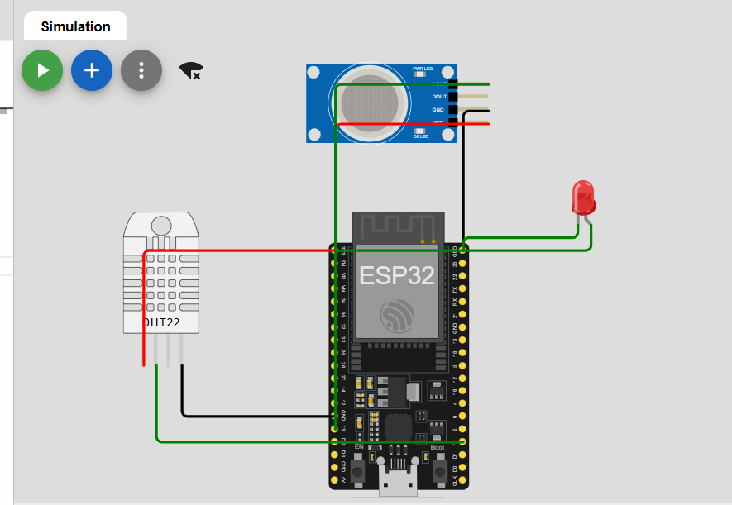

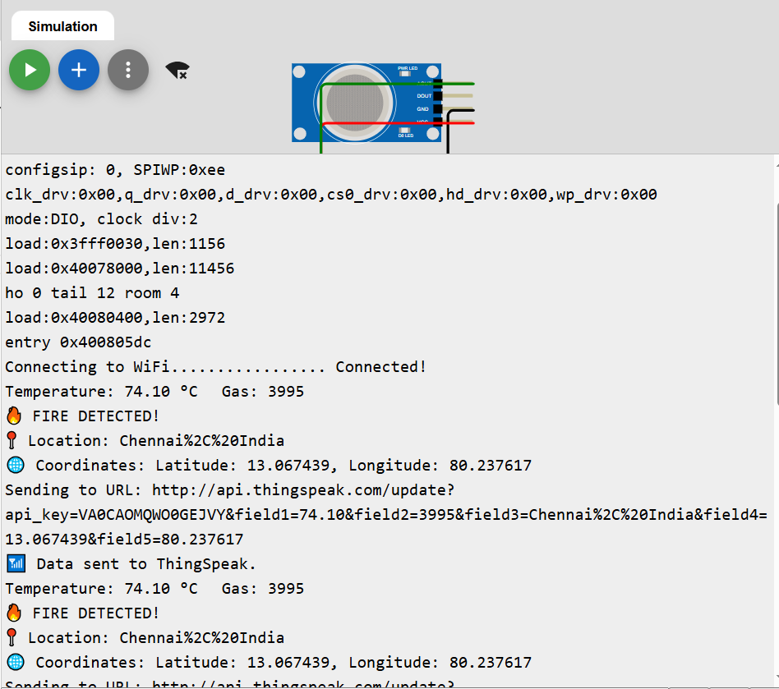
THINKSPEAK CONSOLE:
SITE A-BANGALORE
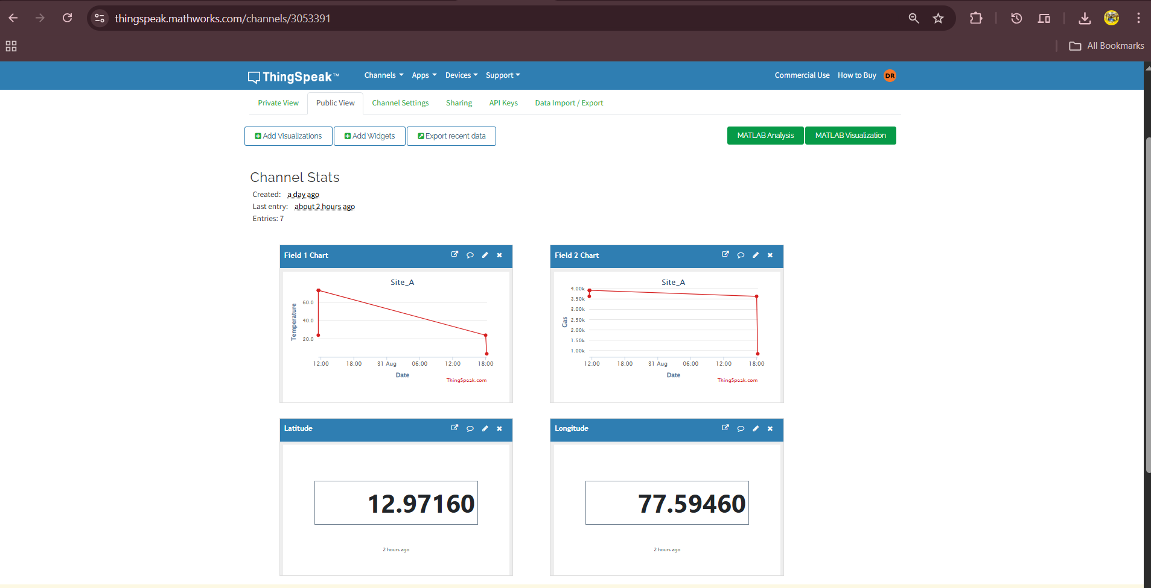

SITE B-CHENNAI:
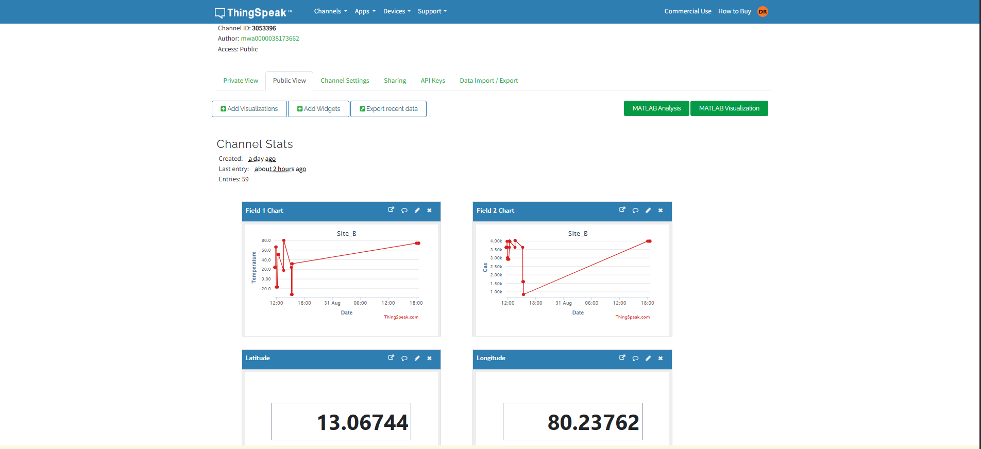
WEB DASHBOARD:
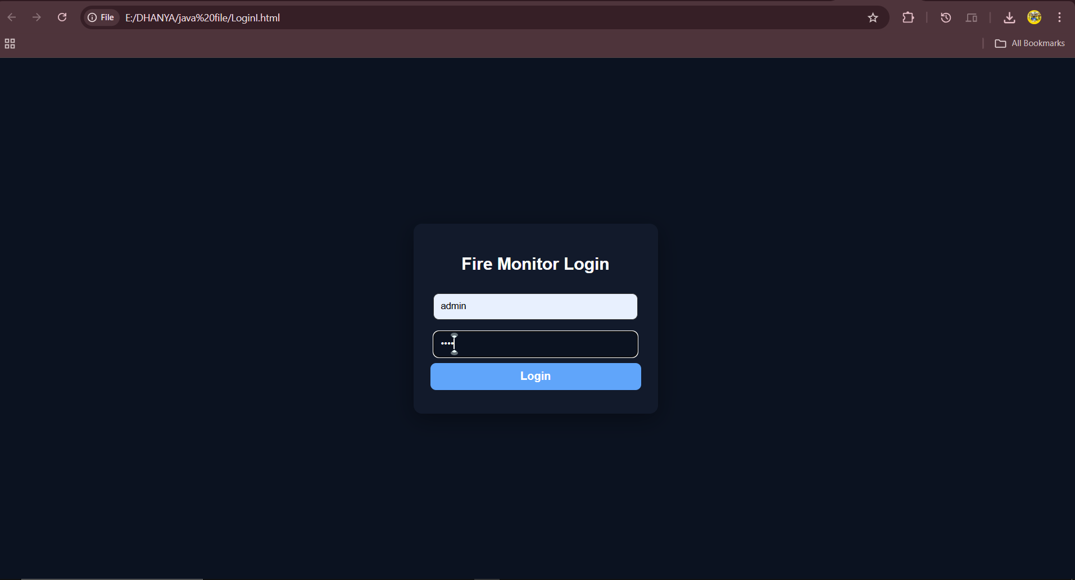
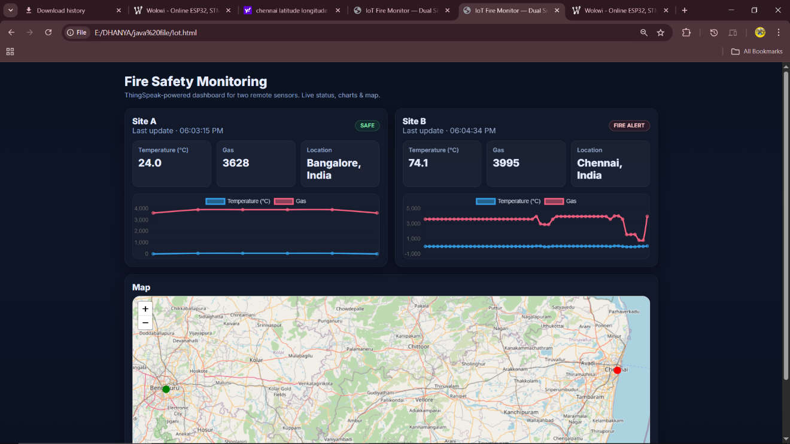

NOTIFICATION:
PHONE MESSAGE ALERT:
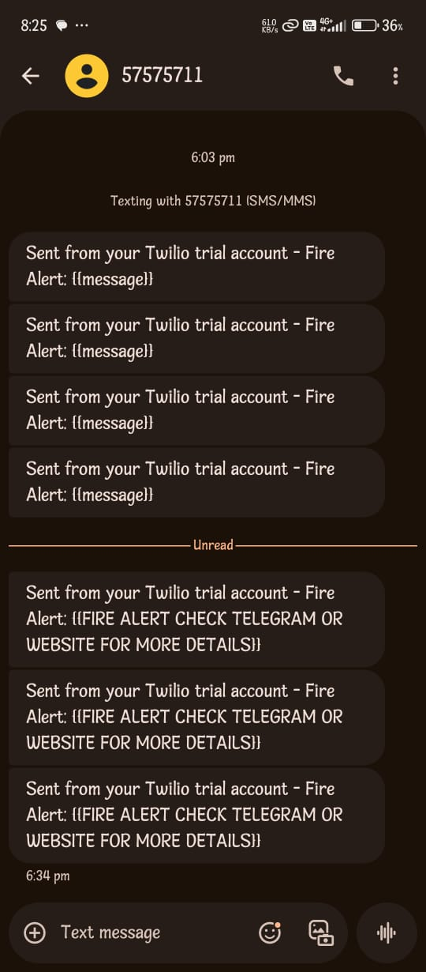
TELEGRAM ALERT NOTIFICATION:
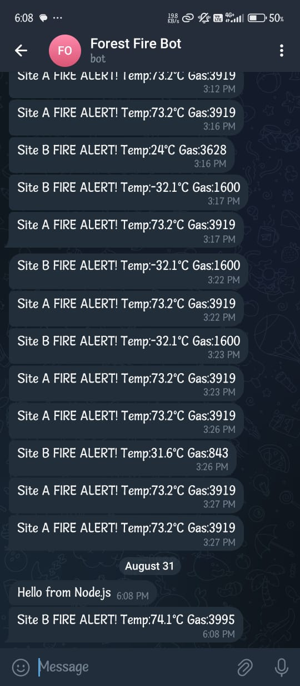

7. CONCLUSION
The IoT-based Forest Fire Detection and Alert System is an innovative solution aimed at mitigating the devastating effects of forest fires by providing early detection and real-time alerts. By integrating ESP32 microcontroller, temperature and gas sensors, ThinkSpeak IoT platform, GPS tracking, and alert services (Telegram and SMS), the system ensures quick response and efficient communication to prevent large-scale damage.
This project demonstrates the potential of IoT in environmental monitoring and highlights how combining hardware and cloud technologies can enhance disaster management systems. The proposed solution is cost-effective, scalable, and reliable, making it suitable for forest authorities, disaster management agencies, and environmental organizations.
In the future, this system can be further enhanced with AI-based fire prediction models, satellite data integration, and solar-powered hardware for completely autonomous operation, ensuring greater sustainability and resilience against natural disasters.

8. BIBLIOGRAPHY

Books
- Rao, P. R. & Kumar, N. (2021). Internet of Things (IoT): Principles and Applications. McGraw-Hill Education.
- Sharma, V. & Singh, A. (2020). IoT-based Fire Detection Systems: A Review. International Journal of Advanced Research in Computer Science, 11(4), 123-129.

Research Papers
• Jha, S. & Mishra, S. (2019). IoT-Based Forest Fire Detection and Alert System Using Wireless Sensor Networks. IEEE International Conference on IoT Systems, pp. 89-94.
• Singh, M. & Kaur, G. (2022). Integration of IoT and Cloud for Real-Time Fire Detection. Journal of Computer Engineering & Applications, 14(6), 101-110.

Websites / Tools
- Wokwi IoT Simulator – https://wokwi.com
  - Used for virtual prototyping and testing ESP32, Arduino, and IoT circuits before real hardware deployment.
- Thinkspeak IoT Platform – https://thingspeak.mathworks.com
  - Cloud platform used for real-time data monitoring, remote device control, and dashboard visualization in IoT applications.
- Node.js– https://nodejs.com
- Twilio- https://console.twilio.com/ - for message notification
- Telegram bot – for message alert
- ESP32 Technical Reference: https://www.espressif.com/en/products/socs/esp32/resources

